**WWS Demo Script**

*Jim,*

*Thanks for taking the time to meet with me today.*

*WorkWave Service is an industry leading field service software that streamlines account management, scheduling, dispatching, routing, invoicing, reporting, connection to the field, and business development. Simply put, WorkWave Service is the most effective tool for your business to reach its full potential.*

*I would like to start with a few slides outlining who WW the company is, what we do, and some of the verticals we serve. Then I’d like to learn more about your business and how we can help. How does that sound?*

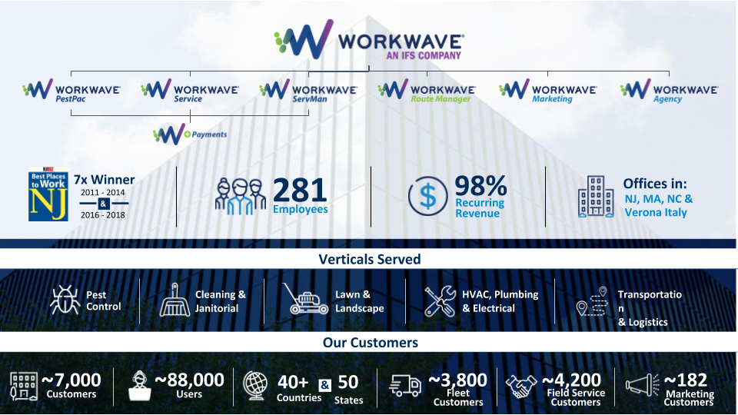

*WorkWave has been around for over 30 years, has over 80,000 users and provides software for field service companies in a multitude of verticals. WorkWave Service is the product that I am focused on. My favorite thing about WWS is it’s versatility. It doesn't limit itself to one particular vertical rather it's so robust YET simple that it can be configured to meet the needs of most field service companies. WWS is all about helping business’s reach their full potential regardless of size or industry.*

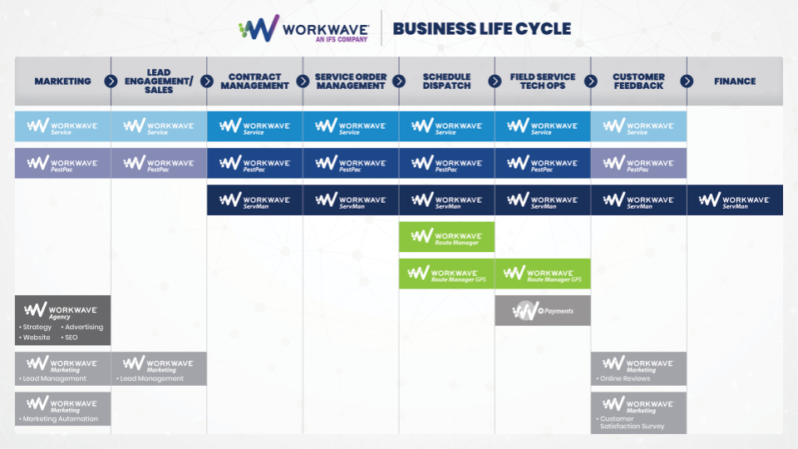

*WorkWave Service will help your business reach its full potential by helping you manage every aspect of the business life cycle. From getting new customers through feedback from customers on service provided and everything in between, WorkWave Service is not just the only tool your business needs but the one it deserves.*

*So that we can use our time most effectively, I just want to take some time to get a better understanding of your current set up.*  (here is where you confirm information passed over from the BDRs or a discovery that the AE had when setting up the demo) *Most companies like you are coming to us because they want to (grow business, increase operational efficiency, running their business using manual methods*

*Questions to ask/confirm*:”

* *You came to us through (Software Advice, filled out a form) Tell me why you are looking for a new platform?*
  + *New Business - Acquire new*
* *Listen for responses - how is x impacting your operations today?*
* *Learn about your prospect’s business issues - is everything done manually? How much time does it take (quantify in hours per week), how does that impact your business? Does it impact AR, does it impact overtime, new sales, lost productivity? Can you quantify that in a dollar amount?*
* *Most of our customers acquire new customers through word of mouth, is that the same for you? How else do you acquire new customers?*
* *What are your goals for the upcoming year?*

**Dashboard**

* Today’s Schedule (Unscheduled, anticipated revenue and service locations)
  + How are you able to view your unscheduled jobs with Google Calendar? Do you have an easy way to see your anticipated revenue for each job/technician?
* Upcoming Schedule. (Make sure you have even distribution)-
  + 80% of capacity is ideal Here is where you can see your upcoming schedule, which technicians are busy/free and where you can schedule any emergency or on the spot jobs.
* Work Order Status (constantly updated by my mobile workforce)
  + Are you easily able to see the status of all of the jobs your teams are working on?
* Estimated to actual
  + quote jobs accurately. What is great about this is if you see that you have a cleaning job that is scheduled for 60 minutes but it routinely takes only 40 minutes, you can adjust the future schedule to give your technicians more time back in his or her day to take on additional jobs.
* Explain AR
* Reviews widget
  + See how many reviews were requested today. As I mentioned earlier WWS can help business development by requesting and posting reviews for you. How do you currently capture reviews from your customers, is it automated or do have to email/call each customer ?
* Online Booking widget
  + Everyone shops for everything online these days, this will allow a prospect or customer to request a service without picking up the phone. Does your website capture and notify you of people needing your service?

**Top Bar**

* Global Search**
  + easily search WWS for accounts, leads, opportunities, contacts via letters or numbers, only 2 characters required! In 2 quick keystrokes you have your entire database at your fingertips. How easy is that? Additionally, you can quickly see an accounts outstanding balance, last and next service date, view account, make payment, create agreement all from this first screen, fast and easy.
* Favorites
  + Each and every user can quickly and easily get to their most frequently visited pages.
* Settings
  + My favorite thing about settings is that it's just as straightforward and easy to navigate as the front end of the software. Gone are the days of being intimidated by messing something up because i'm not a “computer guy”.
* Notes
  + Have something important to tell your tech about a job, does the tech have something to tell the office about a customer? No problem, WWS makes it easy to capture and rely notes from the office or the field.
* Activity log
  + Ever wonder who scheduled that customer or who took that payment? The activity log is a detailed report of all actions by all users.
* Support
  + World class support and training at your fingertips

**Map**

* Quickly and easily see all accounts, opps, and leads on one map. Overlay your service territory and see if it makes sense to broaden or narrow you territory. Maybe your getting interest in an area that has always been deemed as “too far”

**Accounts**

* Easily access and arrange your accounts anyway you need to. Creating an account has never been easier!

**Sales**

* **Lead & Opportunity List**
  + A lot of people I speak to struggle with keeping inbound calls/service requests organized. Does this ring true for you? I also hear the same for prospects/customers that they send pricing to, often follow up is minimal. How much potential revenue is that going to waste? Those days are over with the lead and opportunity lists. Quickly and easily access the list via search bar, observe any notes or follow up dates that are associated. You can even tie the communication hub to these lists and have WWS do your follow ups!
* **Create Agreement**.
  + The following is the most thoughtful and straightforward way of scheduling you will ever see. Whether a simple single one time, multi service and/or day packages that will span an indefinite amount of time, new customers, existing customers, one time or recurring invoicing this process has you covered. Quickly and easily find the best tech/team to assign the job(s) to or set to the side if you are waiting for supplies/parts to come in.
    - Add Service and/or service package
      * Easily edit service(s) to meet customers needs
        + Price
        + Frequency
        + Fixed price, By man hour, Unit of measure
        + Date range
        + Products, materials, discounts
      * Agreement Requires renewal
      * Agreement is a Multi-day project
    - Schedule
      * Software shows which team/tech is closest by understanding the address to be scheduled vs jobs already on calendar
        + Pick specific date range or technician
      * Skip Schedule if not ready to put on calendar
    - Invoicing
      * Confirm billing contact and billing address
      * Billing frequency
        + On completion
        + Recurring
        + On demand
        + Do not invoice
      * Payment authorization
        + Attach cc to agreement for bulk payments

**Scheduling**

* Quickly and easily see how the day is progressing with work order card status colors. In one click access all the important information on the work order. Create new work orders with “quick agreement”. See where your vehicles are via WWGPS on a map in real time! Efficiently oversee your daily operations on one screen. Do you currently have a view that you can all of this information in one cleanly organized location?
* **Route Opt**
  + How much time do you spend organizing routes? How do reschedule rain days/ tech calls out/truck breaks down, etc. What if I tell you that hours worth of work can be done in seconds? Our proprietary routing algorithm understands where each tech starts and finishes for the day, the location of stop, job duration, distance between each stop, historical traffic, and commitment windows. Gone are the days of “2 route sheets and crossing our fingers”.
    - Now that you see how easy our dynamic route optimization is to operate, let me should you the incredible ROI that comes with it ***(route op roi calculator)***
  + Click Appointment Calendar
* Click Dispatch Board**
  + Show how map is interactive by clicking pins to pop out work order card
  + Show gps and review “who’s nearby” button on toolbar
* Quick agreement
  + Great for same day jobs

**Mobile App**

* How does your techs/crews receive and complete their routes & work orders? How do you keep track of their time? Would you like your techs to collect payments in the field? Would you like your tech to be able to request a google review on site? With the WWS mobile app all of that and more is done in a modern straight forward app. Time tracking, directions, “on the way” sms messages, accessing job history, pictures, videos, notes, signatures, payments and much more are all accomplished form the WWS mobile app. Best part is how easy it is to navigate.
  + Works for any android or ios device
  + Time in and out for entire day
  + Turn by turn directions
    - Uses default nav on the device
  + Text on the way message
    - User can select predefined message(s)
  + View Work orders
  + Time in and out of work order
    - Location verification when timing in/out
  + Service location work order history
  + Update or add new service
  + Photos videos notes upload doc from device
  + Capture signatures
  + Capture payment
    - Run CC on mobile app with WWP
  + Request review via mobile app
    - Business reviews required to request reviews from mobile app

**Billing**

* Creating and sending out invoices has never been easier. How much time do you/office staff spend creating invoices? Do you have to sift through illegible handwritten work orders? With a few clicks you can create, email or print all your emails in seconds. How easy was that?
* Work Orders
  + Reconcile work order
  + Close work order
* Invoices
  + Bulk print or email
* Process Payments
* Outstanding Payments.

**Communication**

* How do you currently stay in touch with your customers? Paid service, manually, not at all? What if I told you that WWS can communicate with your customers via email and/or SMS? Then what if I told you it will handle recurring messages (service reminders, outstanding invoices, thank you for scheduling with us, etc.) in addition to one time messages. Did you start providing a new type of service that you would like to let all your customers about? WWS will also track and store every message for each account, if they opened it, when they opened it all while your running the rest of your business. Pretty awesome right?

**Reporting**

* Do you struggle generating the type of reporting that is crucial to your business? Is it hard to organize all the information you have about your business and/or customers? Do you have any state mandated reports ? With WWS you have access to all the data that makes up your company and gives you the ability to arrange it in a way that matters most to you.
  + List reports for custom reporting and communication hub
  + Scheduling Reports for route sheet, bulk work orders, time in/out actual vs est
  + Billing reports for AR, revenue, sales tax, customer ledger, payments
  + GPS reports for event reporting
  + Timesheet reports for exporting time in/out data
  + Activity report for everything that has happened in WWS since day 1
  + Report writer for those that like/need extremely detailed reporting with graphs and charts

**Employee’s**

* **H**ow do you currently track your tech/team time? Punchclock, written on route sheet, not at all? Any user can time in and out for the day, work order, lunch, or breaks. WWS will capture and organize on the employees time sheet.

<https://docs.google.com/document/d/1tPkWrz_Ph_fvvrrQ4tPdkG4meNH6ZNWp3reEmtxuxPU/edit>