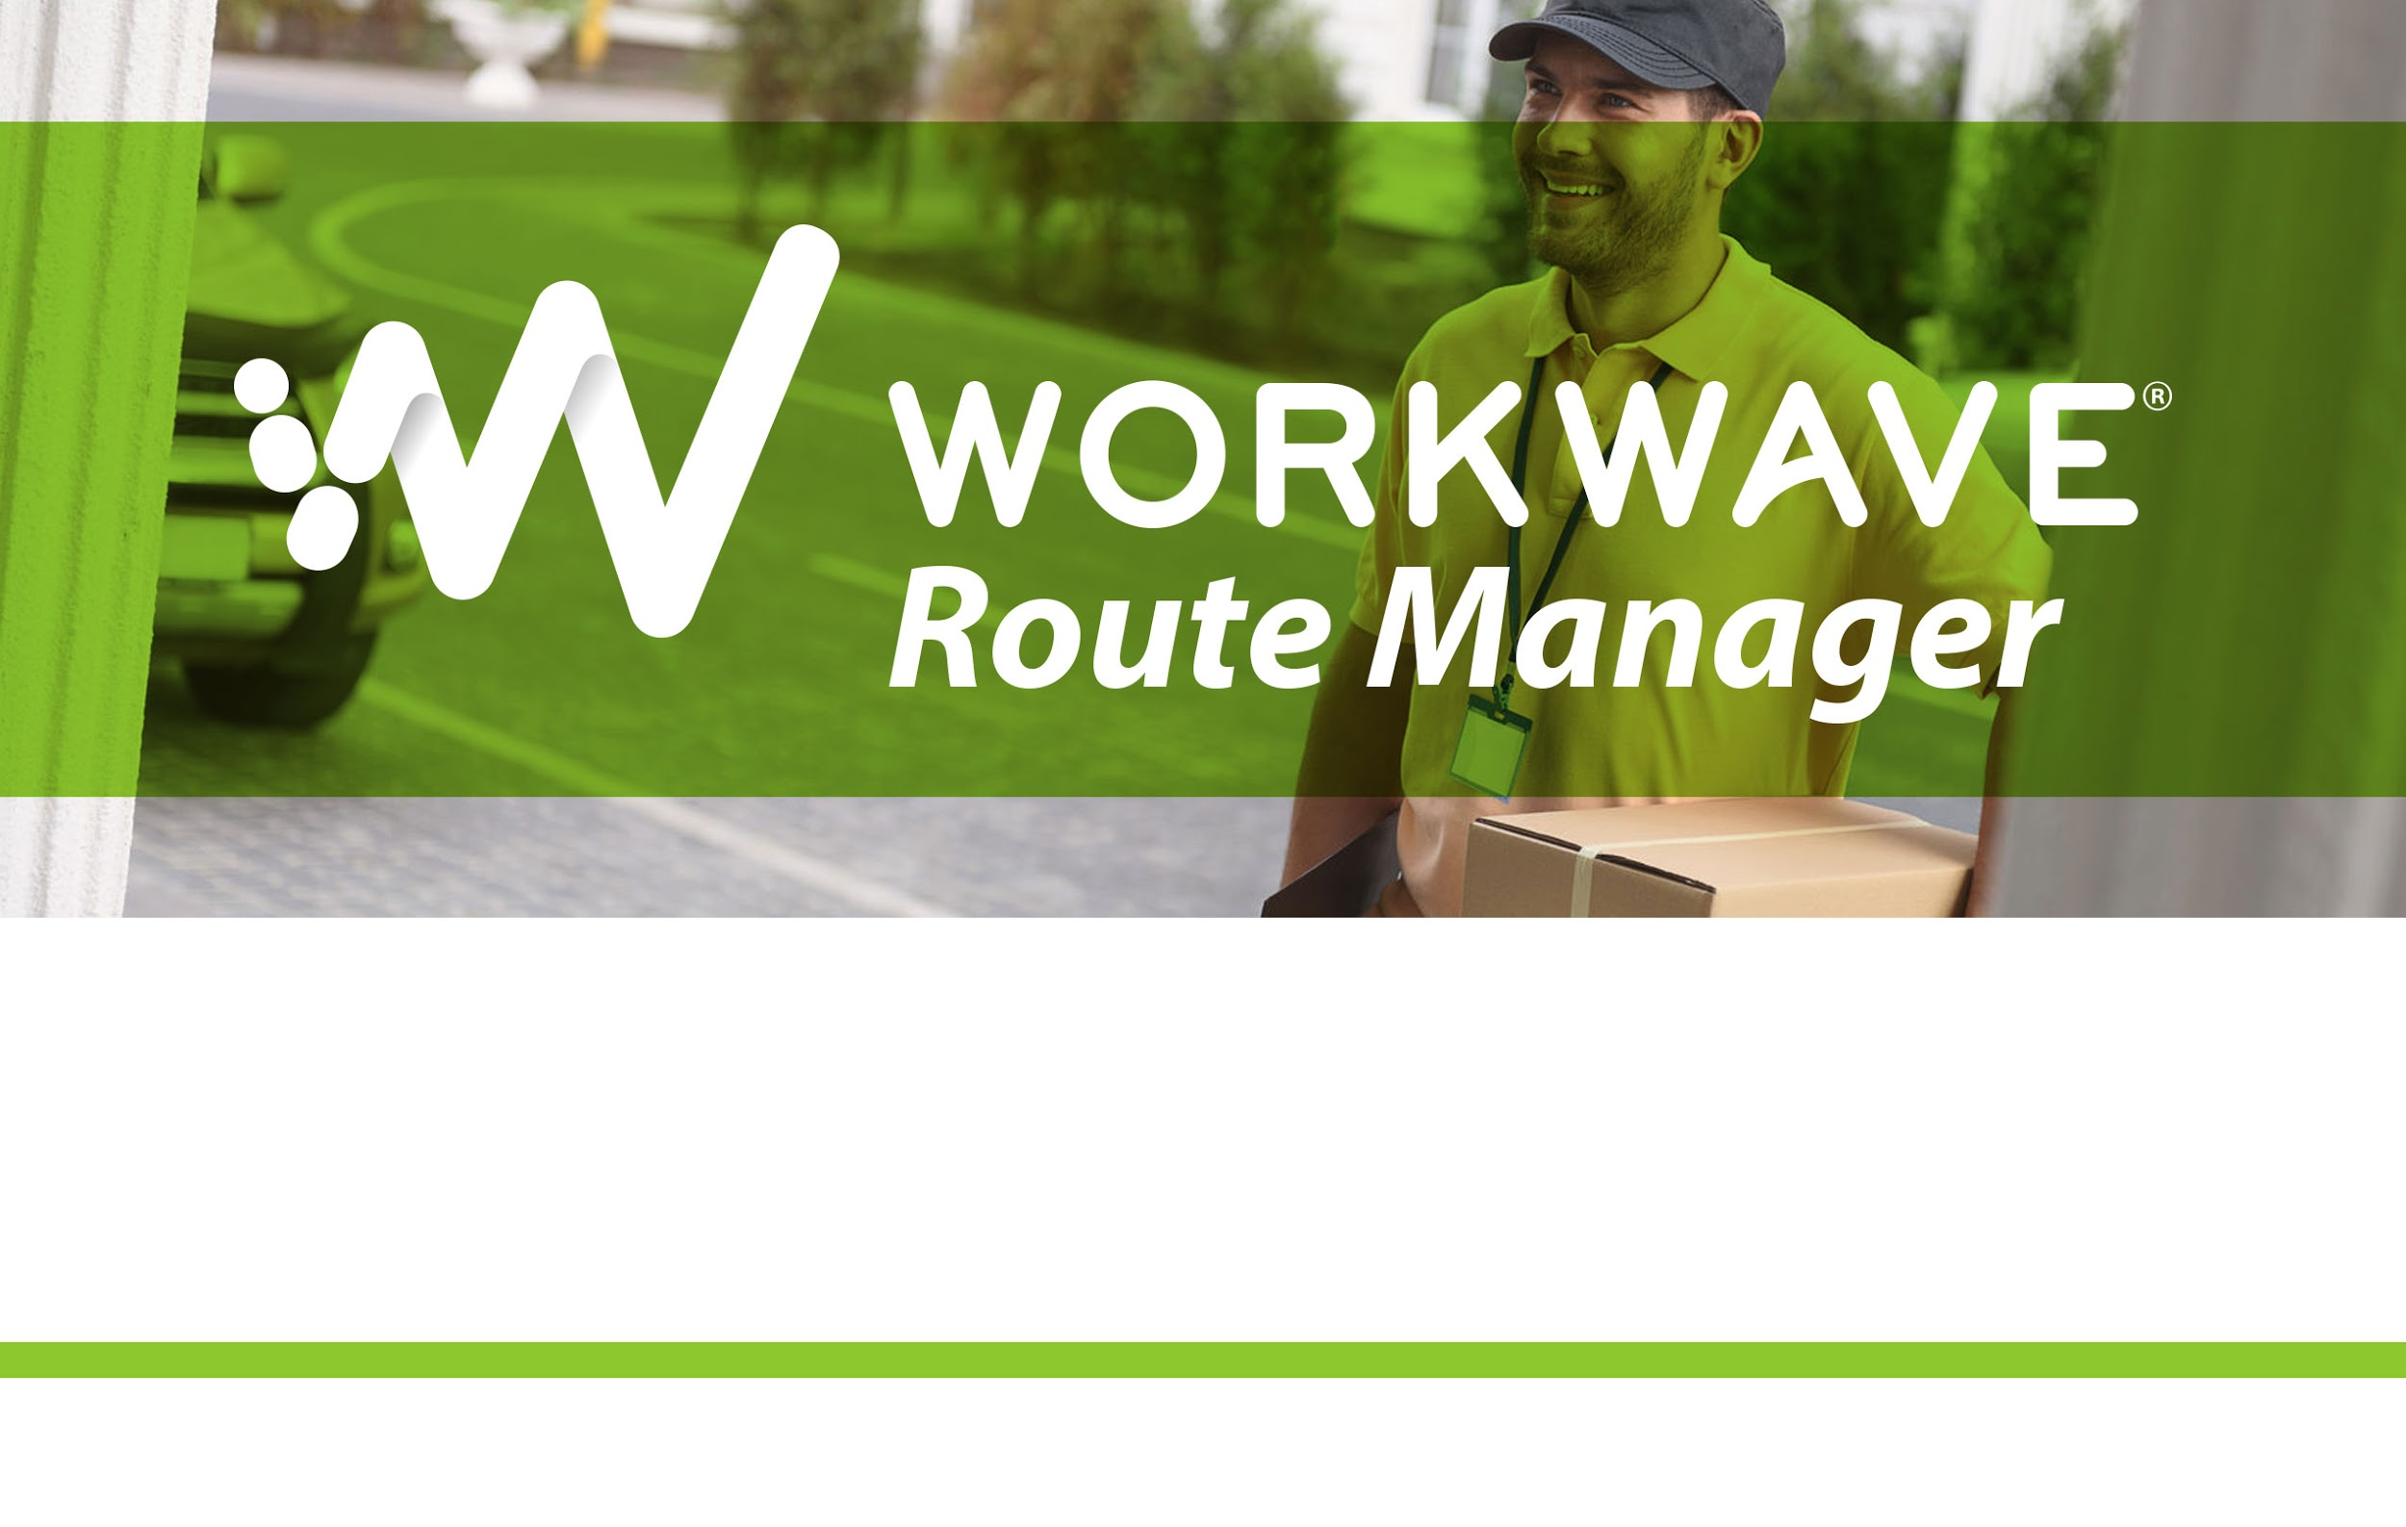
WorkWave Route Manager 360
101 Crawfords Corner Road, Suite 2511, Holmdel, NJ 07733 • 800.762.0301 • 732.938.7950 • fax: 732.938.7951

Onboarding

Table of Contents
Onboarding process 3
Integration API Onboarding 3
Route Manager and GPS Operation Console Onboarding 3
Training Session 1 (1st session) - Setup 3
Training Session 2 (2nd session) - Planning 4
Training Session 3 (3rd session) – advanced settings 4
Mobile Application Usage Onboarding 4

Onboarding process
The customer will be helped by Partnername team to onboard the new technology.
Given the cloud based type of the service implies no installation/management training but only usage and integration support.

There will be 3 types of training for onboarding targeted at the different users:
- Integration API onboarding
- Route Manager 360 onboarding (for dispatcher)
- Mobile application usage onboarding (for drivers)

Integration API Onboarding
Integration can be done using WorkWave REST API technology.
Partnername team will help the customer automate the order import into Route Manager.
Specific documentation and examples are available here.

Route Manager Onboarding
This training is dedicated to the operation manager/dispatcher and is intended as a “train the trainer” process. The trained individual(s) will train the all of the dispatchers.
Individuals working on the console will receive a dedicated training with the following schedule:

Training Session 1 (1st session) - Setup
- Configuring your environment
- Define your territory/ies
- Define your depots
- Define your vehicles
  - Create all exceptions with customer (Sats, Suns, Holidays, etc)
  - Hours
  - Breaks
  - Skills
  - Loads
  - Speed
  - Costs
- Define your regions

Training Session 2 (2nd session) - Planning
- Access WW support portal
- Support button and process
- Geocoding process and limitations
- Build plan
- Manual changes
- Drag and drop
- Plan approval
- Check in/out
- Proofs of delivery

Training Session 3 (3rd session) – advanced settings
- Force fit
- Best Fit/Fit in Unassigned Orders
- Simulation needs
- Define traffic regions
- Model your vehicle, customize territory.

Mobile Application Usage Onboarding
This training is dedicated to the people that will train the driver on how to use the mobile app.
- Login the mobile app
- List the route for today/next days
- Refresh the list and notification of changes
- Control the details of delivery/pickup
- Check in/out at the destination
- Provide Proofs of Delivery

Select preferred navigation app

